Technical Skill Assessment

In this scenario the business needs to know who has passed their year at an educational institute. To pass, a student must have gained at least 3 C grades or above in any subjects.

The data access layer has been provided for you. It is in a separate class library, named DataAccess. There is a class within this library called DataAccessor, this has all the data you need in order to complete this task.

We need a very simple web display (style is not important) that shows a table with the following information: The Student with his\her completed courses and grades and an identifier to show if he\she has passed the year.

Something like this is fine:

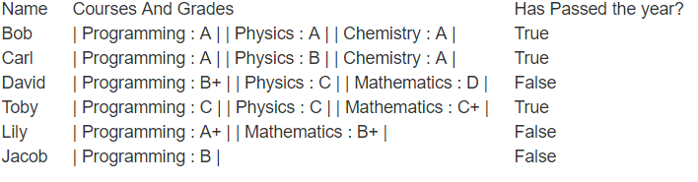

Note: Feel free to use the ‘FrontEnd’ project that exists to create the view that will display the above output.

What we are looking for:

* Neat code.
* Succinct code additions for the best possible solution.
* The solution must work with the given data structure, **modifications to the DataAccess and Entities projects are not allowed.**
* Don’t worry if the code isn’t complete. We will still look at what has been done.

Feel free to use the internet.

Have fun!